**Miguel Martins Student ID: m228540**

**Progress report 2.**

**First aim:**

Update lathe’s bed

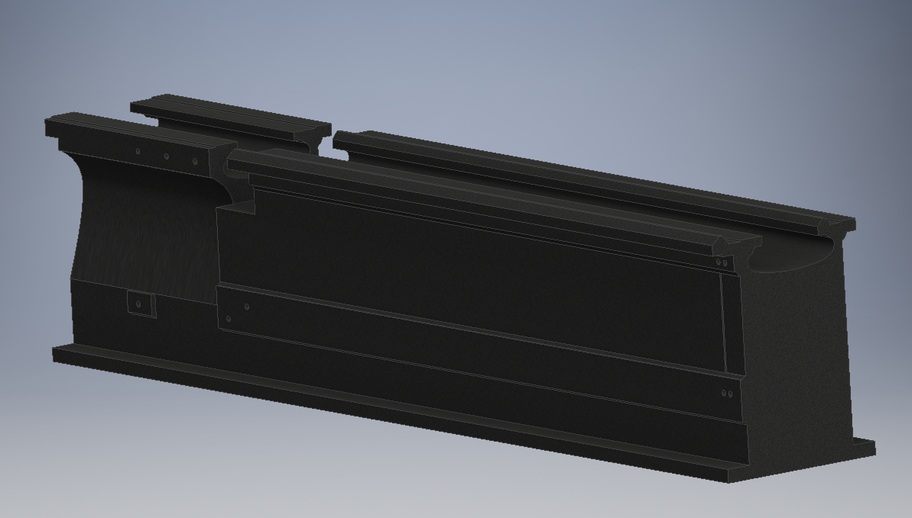

* Creation of holes to allocate motor and ball screw supports.
* Determine and specify the exact dimension and position of a zone to be grinded.
* Minor general dimension changes.

**Second aim:**

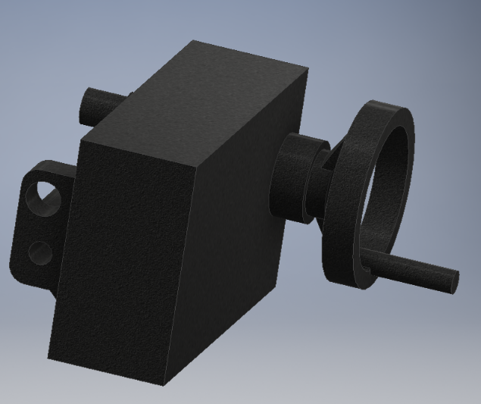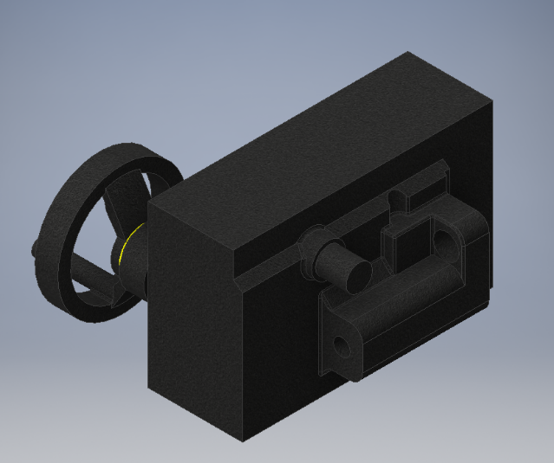Create an editable and 3D model of the lathe’s apron.

Model includes material.

**Third aim:**

Elaborate a digital representation of the ball screw, nut and its support.

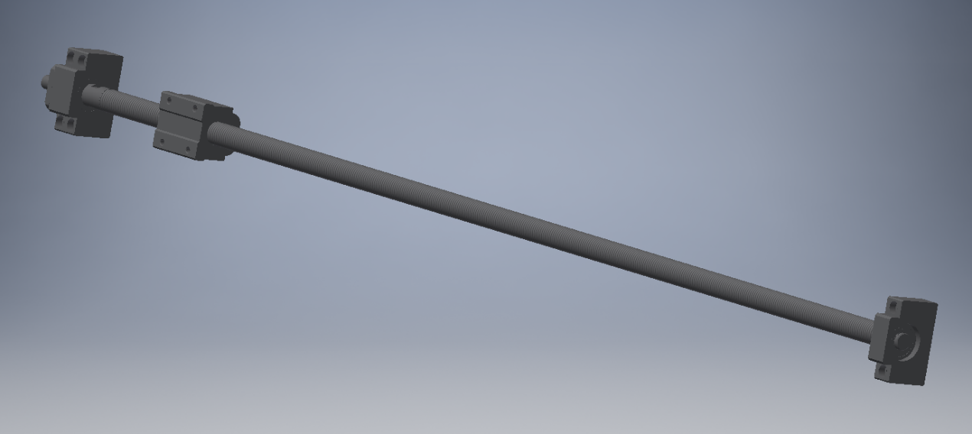

Found and generated online on the THK company website based on previous calculations carried out in the progress report 1. (<http://www.thkstore.com/bnt-nut.html>).

**Fourth aim:**

Assemble available parts into a restricted model.

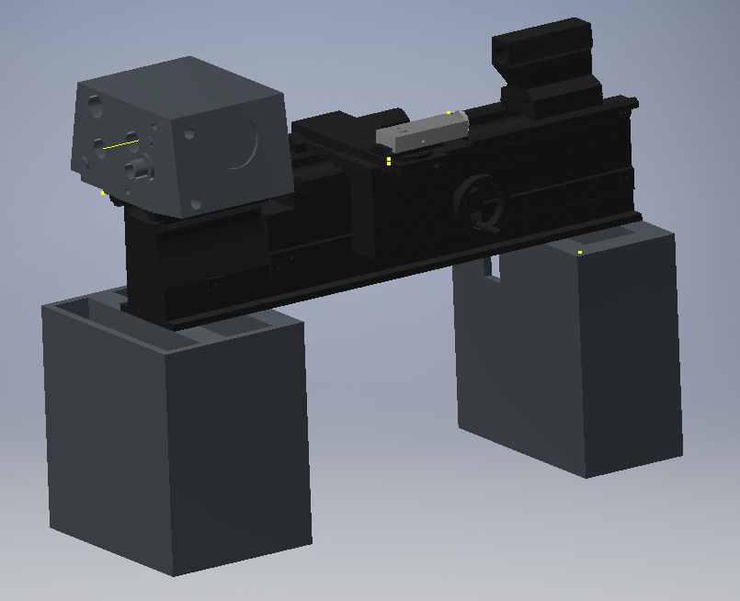

**Fifth aim:**

Design supports for both motor and ball screw and find the most suitable allocation for it on the bed.

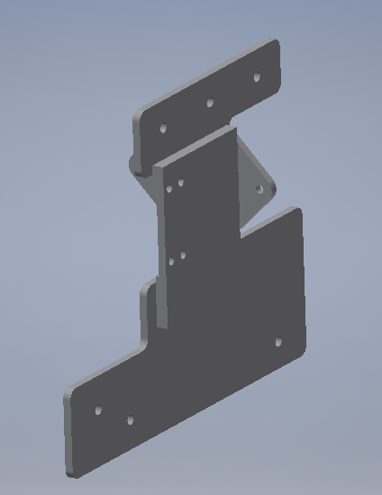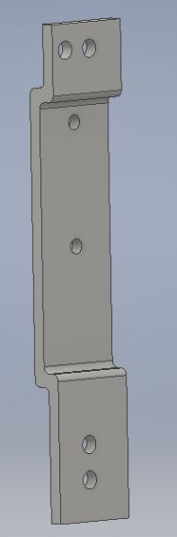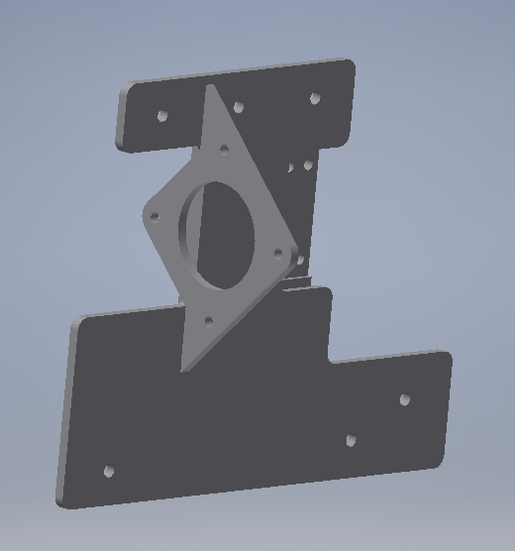

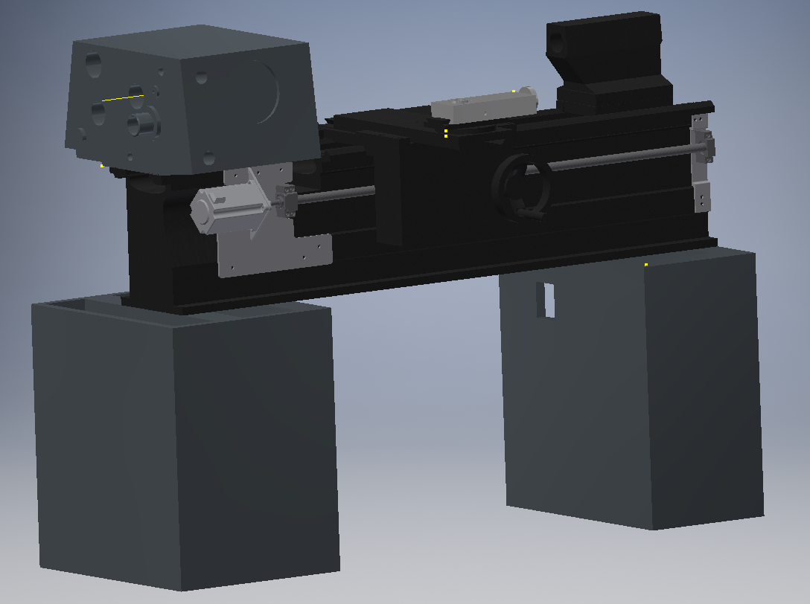

**Sixth aim:**

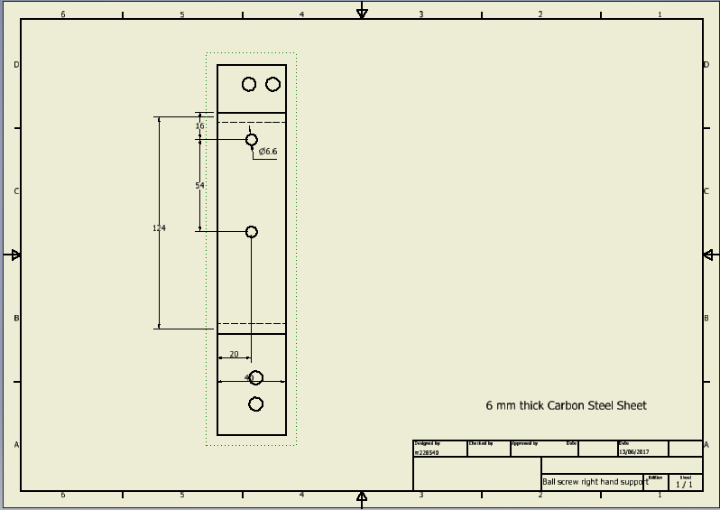Produce manufacturing drawings for supports.

